

UNIVERSITY OF SCIENCE AND TECHNMOLOGY HOUARI BOUMEDIAN

A TRIP INTO THE WORLD OF ICT AKA

I : INFORMATION C :COMMUNICATION T :TECHNOLOGY

PRISENTED BY THE STUDENT : Elwazir Mohamed

SECTION :C

GROUP : 3

DATE : 3 /JANVIER/2024

s

Definition : 3

History 5

FINANCE 7

Humanity 8

Technologies related to ICT 12

Google services 12

Microsoft tools 13

Git and github 14

Artificial intelligence 15

Etc … 15

# Definition :

Information and Communication Technology (ICT) serves as an expansive term encompassing Information Technology (IT) while highlighting the significance of cohesive communications. It underscores the amalgamation of telecommunications (encompassing telephone lines and wireless signals) and computers, coupled with essential enterprise software, middleware, storage, and audiovisual components. This amalgamation empowers users to seamlessly access, store, transmit, comprehend, and manipulate information

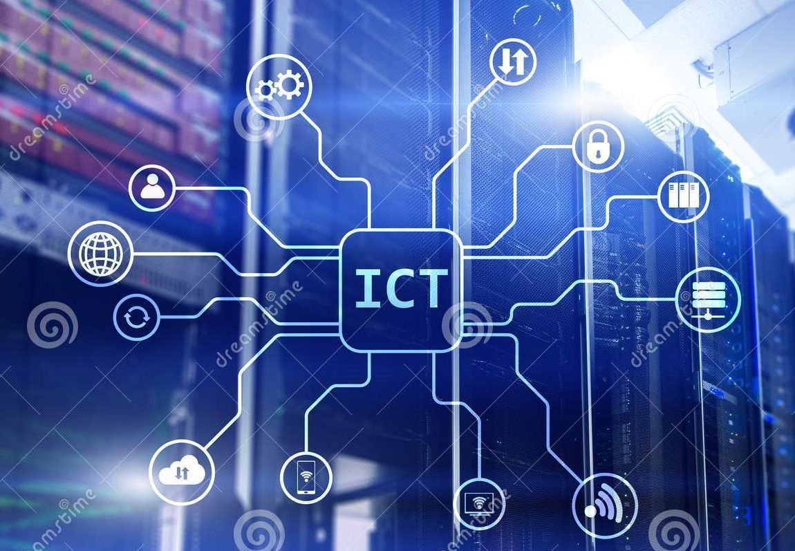

A photo describes the relation between ITC archean contents

Furthermore, ICT extends to the convergence of audiovisuals and telephone networks with computer networks through a unified cabling or link system. There exist substantial economic incentives in consolidating telephone networks with computer networks into a singular, unified system of cabling, signal distribution, and management. The term ICT serves as an umbrella, encompassing a wide array of communication devices such as radio, television, cell phones, computer and network hardware, satellite systems, and more. It also includes various services and appliances like video conferencing and distance learning. Analog technologies like paper communication and any mode facilitating communication transmission are also part of the ICT domain

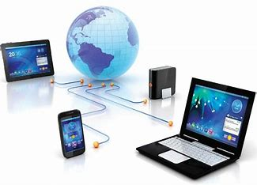

The relation between different technologies and there abilities in human communications

Given its broad nature, ICT is a continually evolving subject, with concepts that span any product capable of electronically storing, retrieving, manipulating, transmitting, or receiving information in digital form. This includes diverse entities like personal computers (including smartphones), digital television, email and robots.

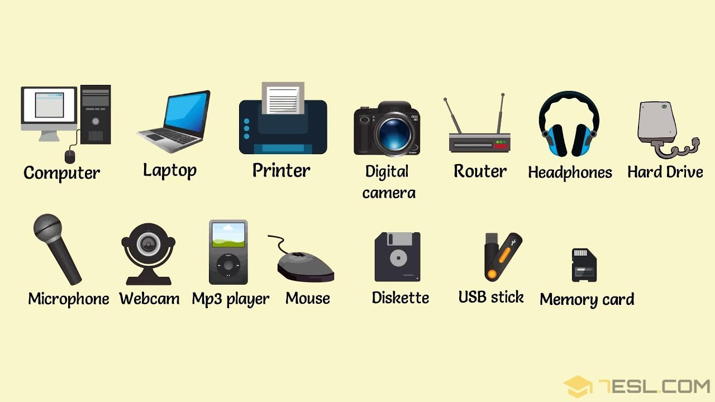

Electronic devices used in human communication (as it self or as parts of other machines)

To squeeze the juice of This research we can take an overlook of ICT into three main sub heading

## History

narrative woven through the tapestry of human history, marked by key dates and visionary figures. The ancient Sumerians, around 3500 BCE, introduced the earliest form of writing on clay tablets The trajectory of Information and Communication Technology (ICT) is a fascinating, a pivotal moment that laid the foundation for recorded communication. Fast forward to 1440 when Johannes Gutenberg's printing press revolutionized information dissemination during the Renaissance, democratizing access to knowledge.

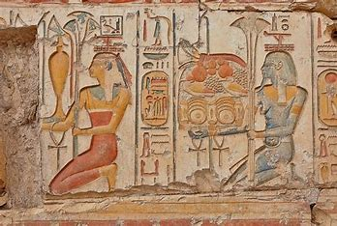

An ancient method of communication before technology

In the 19th century, Samuel Morse's development of the telegraph in 1837 transformed long-distance communication. Alexander Graham Bell's invention of the telephone in 1876 further propelled human connectivity. The 20th century witnessed significant strides, notably with Alan Turing's contributions to early computing during World War II, setting the stage for the digital age.

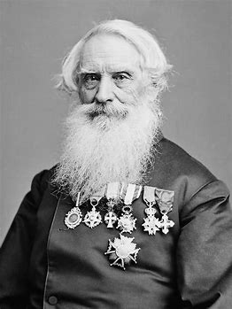 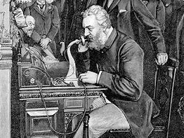 

Samuel morse graham bell alan turing

The 1960s and 1970s witnessed the birth of the internet. In 1969, ARPANET, the precursor to the internet, came to life. Tim Berners-Lee's invention of the World Wide Web in 1989 fueled the explosion of online information. Mobile communication took center stage in 1973 when Martin Cooper made the first handheld mobile phone call. Steve Jobs' introduction of the iPhone in 2007 marked a watershed moment, combining communication, computing, and entertainment in a handheld device.

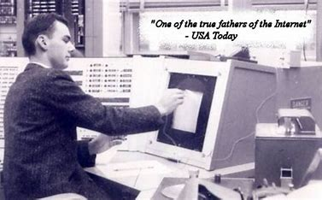

Man using the computer for the first time in his life

As we reflect on these historical milestones, it becomes clear that the development of ICT is an intricate tapestry interwoven with the brilliance of numerous minds across diverse eras, each contributing a thread to the complex narrative of human connectivity.

## 

## FINANCE

## 

|  |  |
| --- | --- |
| date | Financial events |
| 1920s_1930s | The early groundwork for electronic computing systems was laid during this period. Pioneering technologies like punched-card machines were used for basic financial calculations and record-keeping. |
| 1950s_1960s | Mainframe computers began to be employed by financial institutions for complex calculations and data processing. This era marked the initial steps towards automating financial tasks. |
| 1970s_1980 | he advent of mini-computers brought computing power to a broader range of financial organizations. Electronic trading systems emerged, transforming how financial assets were bought and sold. |
| 1990s_2000s | he dot-com boom witnessed a surge in technology-related investments, including the development of financial technology (FinTech) startups. The subsequent bust led to increased scrutiny, but key FinTech innovations emerged. |
| 2010s_2020 | the rise of FinTech gained momentum, driven by advancements in ICT. Mobile banking, digital wallets, peer-to-peer lending, and robo-advisors reshaped traditional financial services. Blockchain and cryptocurrencies introduced decentralized finance (DeFi) alternatives |
| 2020_now | The financial industry continues to be shaped by ICT, with a focus on cybersecurity, real-time data analytics, and the integration of emerging technologies like blockchain and quantum computing. |

## 

## 

## Humanity

1. **Enhanced Communication:**
   * **Global Connectivity:** ICT has connected people across the globe, facilitating instant communication through emails, social media, video conferencing, and messaging apps.
   * **Real-Time Information:** The ability to access and share information in real-time has transformed how individuals, businesses, and governments communicate.



Friend group chat

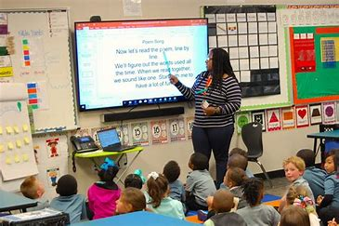

. teacher uses a reactive screen to teach

1. **Healthcare Advancements:**
   * **Telemedicine:** ICT allows for remote medical consultations, enabling individuals to receive healthcare services without physical presence.
   * **Health Information Systems:** Electronic health records and data analytics have improved patient care, research, and disease management.



Hearing technological device

1. **Business and Economic Growth:**
   * **Efficient Operations:** ICT tools and systems have streamlined business processes, improving efficiency and productivity.
   * **Global Market Access:** Businesses can reach a global audience through online platforms, expanding market opportunities and economic growth.



**La bourse**

1. **Research and Innovation:**
   * **Data Analysis:** ICT facilitates the collection and analysis of vast amounts of data, accelerating scientific research and innovation.
   * **Collaborative Tools:** Researchers across the world can collaborate in real-time, accelerating the pace of discovery and development.
2. **Social Impact:**
   * **Community Building:** Social media platforms and online forums have enabled the creation of virtual communities, fostering collaboration and support.
   * **Awareness and Activism:** ICT has played a crucial role in raising awareness about social issues and promoting activism through online campaigns.

# Technologies related to ICT

## Google services

Google Services constitute a comprehensive suite of online tools and applications developed by Google, serving a multitude of purposes and enhancing various aspects of users' digital lives. These services span across communication, productivity, entertainment, and information retrieval. Here are some key Google services:

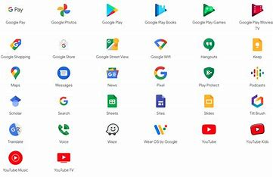

A bunch of google services

1. **Google Search:**
   * **Purpose:** The most widely used search engine globally, Google Search provides users with access to a vast repository of information on the internet.
   * **Features:** Advanced search algorithms, personalized results, and features like Google Images, News, and Maps integrated into search results.
2. **Gmail:**
   * **Purpose:** Gmail is Google's email service, offering efficient and feature-rich email management for individuals and businesses.
   * **Features:** Robust spam filtering, organized inbox with categories, and seamless integration with other Google services.
3. **Google Drive:**
   * **Purpose:** A cloud storage service, Google Drive enables users to store, share, and collaborate on documents, spreadsheets, presentations, and more.
   * **Features:** Real-time collaboration, file version history, and integration with Google Workspace applications.
4. **Google Docs, Sheets, and Slides:**
   * **Purpose:** Part of Google Workspace, these applications provide online document creation, editing, and collaboration.
   * **Features:** Real-time collaboration, comment and suggestion features, and cloud-based storage.
5. **Google Calendar:**
   * **Purpose:** A scheduling and time management tool, Google Calendar helps users organize their events, appointments, and schedules.
   * **Features:** Integration with Gmail, reminders, and the ability to share calendars for collaborative scheduling.

## Microsoft tools

Microsoft Tools encompass a diverse and comprehensive suite of software applications and services developed by Microsoft Corporation, catering to a wide range of user needs in both personal and professional settings. Here are some key Microsoft tools:

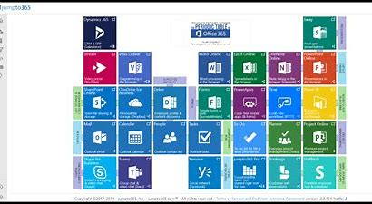

Microsoft most important tools

1. **Microsoft Office 365:**
   * **Purpose:** A cloud-based suite of productivity tools designed for document creation, collaboration, and communication.
   * **Components:** Microsoft Word, Excel, PowerPoint, Outlook, OneNote, and more.
   * **Features:** Real-time collaboration, cloud storage with OneDrive, and cross-platform accessibility.
2. **Microsoft Teams:**
   * **Purpose:** A collaboration platform that integrates chat, video conferencing, file sharing, and application integration.
   * **Features:** Team channels, video meetings, file collaboration, and integration with other Microsoft 365 apps.
3. **Microsoft SharePoint:**
   * **Purpose:** A web-based collaboration platform that enables organizations to create, manage, and share content and applications.
   * **Features:** Document management, workflow automation, and team collaboration sites.
4. **Microsoft Azure:**
   * **Purpose:** A comprehensive cloud computing platform that provides a wide range of services, including computing power, storage, and databases.
   * **Features:** Virtual machines, databases, AI and machine learning services, and scalable cloud infrastructure.
5. **Windows Operating System:**
   * **Purpose:** Microsoft's flagship operating system used on a majority of personal computers.
   * **Features:** Regular updates, user-friendly interface, and compatibility with a wide range of software and hardware.

## Git and github

**Git:**

**Purpose:** Git is a distributed version control system designed to track changes in source code during software development. It enables collaboration among multiple developers working on the same project and provides a history of changes, making it easier to manage and maintain code.

**GitHub:**

**Purpose:** GitHub is a web-based platform built around Git, providing hosting for software development and collaboration. It enhances the Git workflow by adding features such as a graphical interface, issue tracking, and pull requests.



## Artificial intelligence

Artificial Intelligence (AI) refers to the simulation of human intelligence in machines programmed to perform tasks that typically require human intelligence. It encompasses a broad range of techniques and technologies that enable machines to learn, reason, perceive, and make decisions. Here are key concepts of artificial intelligence:

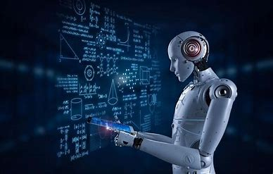

An imaginary photo of artificial intelligence in the future

1. **Machine Learning (ML):**
   * A subset of AI that involves the development of algorithms allowing machines to learn from data.
   * Types include supervised learning, unsupervised learning, and reinforcement learning.
2. **Deep Learning:**
   * A type of machine learning that utilizes neural networks with multiple layers (deep neural networks).
   * Particularly effective in tasks such as image and speech recognition.
3. **Natural Language Processing (NLP):**
   * Enables machines to understand, interpret, and generate human language.
   * Used in chatbots, language translation, and sentiment analysis.
4. **Computer Vision:**
   * Empowers machines to interpret and make decisions based on visual data.
   * Applications include facial recognition, object detection, and image analysis.

## Etc …